Mass
# Source: AI Source: Provided by: [Data Path: Persons Table -> ID Column: 1, Name_En Column: Motasem Essam] -> From: [ChatGPT] on [7/17/2026]
Mass is the measurement of the amount of matter contained in an object. It is one of the seven base quantities in the International System of Units (SI) and is a fundamental concept in physics, chemistry, engineering, manufacturing, and everyday life.
Unlike weight, which depends on gravity, mass remains constant regardless of location.

Definition
# Source: AI Source: Provided by: [Data Path: Persons Table -> ID Column: 1, Name_En Column: Motasem Essam] -> From: [ChatGPT] on [7/17/2026]
Mass is the physical quantity that measures the amount of matter in an object.
The SI base unit of mass is the kilogram (kg).

Purpose
# Source: AI Source: Provided by: [Data Path: Persons Table -> ID Column: 1, Name_En Column: Motasem Essam] -> From: [ChatGPT] on [7/17/2026]
Mass measurement is used to:
- Determine the amount of matter in an object.
- Compare objects.
- Calculate density.
- Perform scientific experiments.
- Manufacture products.
- Measure ingredients.
- Support trade and commerce.

SI Unit
# Source: AI Source: Provided by: [Data Path: Persons Table -> ID Column: 1, Name_En Column: Motasem Essam] -> From: [ChatGPT] on [7/17/2026]
The SI base unit of mass is:
1 kilogram (kg) ​
Since 2019, the kilogram has been defined by fixing the numerical value of the Planck constant, making it independent of any physical artifact.

Common Units of Mass
# Source: AI Source: Provided by: [Data Path: Persons Table -> ID Column: 1, Name_En Column: Motasem Essam] -> From: [ChatGPT] on [7/17/2026]
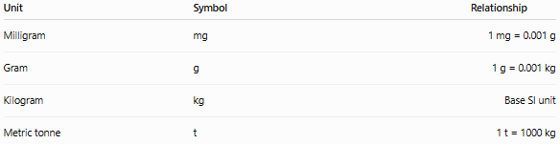
Unit | Symbol | Relationship
Milligram | mg | 1 mg = 0.001 g
Gram | g | 1 g = 0.001 kg
Kilogram | kg | Base SI unit
Metric tonne | t | 1 t = 1000 kg

Common Imperial and USCS Units
# Source: AI Source: Provided by: [Data Path: Persons Table -> ID Column: 1, Name_En Column: Motasem Essam] -> From: [ChatGPT] on [7/17/2026]
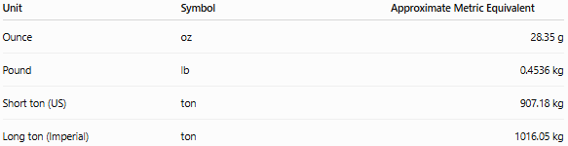
Unit | Symbol | Approximate Metric Equivalent
Ounce | oz | 28.35 g
Pound | lb | 0.4536 kg
Short ton (US) | ton | 907.18 kg
Long ton (Imperial) | ton | 1016.05 kg

Measuring Instruments
# Source: AI Source: Provided by: [Data Path: Persons Table -> ID Column: 1, Name_En Column: Motasem Essam] -> From: [ChatGPT] on [7/17/2026]
Mass is commonly measured using:
- Beam balance
- Electronic balance
- Analytical balance
- Laboratory balance
- Weighing scale

Measurement Process
# Source: AI Source: Provided by: [Data Path: Persons Table -> ID Column: 1, Name_En Column: Motasem Essam] -> From: [ChatGPT] on [7/17/2026]
To measure mass:
- Select an appropriate balance or scale.
- Zero (tare) the instrument if necessary.
- Place the object on the measuring platform.
- Read the displayed or indicated value.
- Record the measurement with the correct unit.

Examples
# Source: AI Source: Provided by: [Data Path: Persons Table -> ID Column: 1, Name_En Column: Motasem Essam] -> From: [ChatGPT] on [7/17/2026]
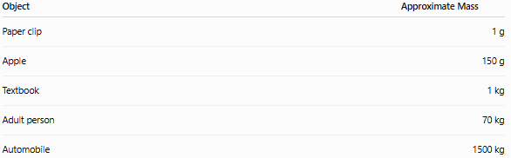
Object | Approximate Mass
Paper clip | 1 g
Apple | 150 g
Textbook | 1 kg
Adult person | 70 kg
Automobile | 1500 kg

Unit Conversions
# Source: AI Source: Provided by: [Data Path: Persons Table -> ID Column: 1, Name_En Column: Motasem Essam] -> From: [ChatGPT] on [7/17/2026]
Common metric conversions:
- 1 kg = 1000 g
- 1 g = 1000 mg
- 1 tonne = 1000 kg
Examples:
- 2 kg = 2000 g
- 750 g = 0.75 kg
- 5 tonnes = 5000 kg

Accuracy
# Source: AI Source: Provided by: [Data Path: Persons Table -> ID Column: 1, Name_En Column: Motasem Essam] -> From: [ChatGPT] on [7/17/2026]
Accurate mass measurement depends on:
- Proper instrument calibration.
- Stable environmental conditions.
- Correct zero adjustment.
- Proper placement of the object.

Precision
# Source: AI Source: Provided by: [Data Path: Persons Table -> ID Column: 1, Name_En Column: Motasem Essam] -> From: [ChatGPT] on [7/17/2026]
Precision refers to how closely repeated mass measurements agree.
Example:
- 100.02 g
- 100.01 g
- 100.03 g
These measurements are highly precise.

Mass vs. Weight
# Source: AI Source: Provided by: [Data Path: Persons Table -> ID Column: 1, Name_En Column: Motasem Essam] -> From: [ChatGPT] on [7/17/2026]
Mass and weight are related but are not the same quantity.
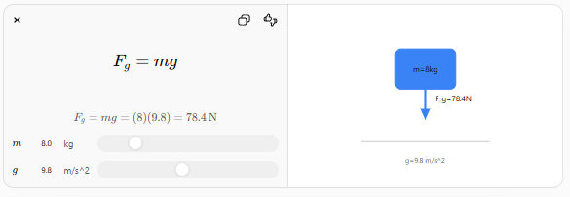
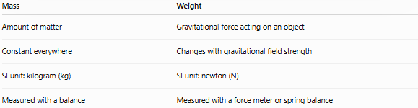
Mass | Weight
Amount of matter | Gravitational force acting on an object
Constant everywhere | Changes with gravitational field strength
SI unit: kilogram (kg) | SI unit: newton (N)
Measured with a balance | Measured with a force meter or spring balance

Applications
# Source: AI Source: Provided by: [Data Path: Persons Table -> ID Column: 1, Name_En Column: Motasem Essam] -> From: [ChatGPT] on [7/17/2026]
Mass measurement is essential in:
- Physics
- Chemistry
- Engineering
- Manufacturing
- Medicine
- Agriculture
- Food production
- Pharmaceutical industry
- Scientific research
- Commerce

Everyday Importance
# Source: AI Source: Provided by: [Data Path: Persons Table -> ID Column: 1, Name_En Column: Motasem Essam] -> From: [ChatGPT] on [7/17/2026]
Mass measurement is used daily for:
- Buying groceries.
- Cooking ingredients.
- Shipping packages.
- Measuring medicine.
- Weighing luggage.
- Manufacturing products.
- Laboratory experiments.

Common Mistakes
# Source: AI Source: Provided by: [Data Path: Persons Table -> ID Column: 1, Name_En Column: Motasem Essam] -> From: [ChatGPT] on [7/17/2026]
- Confusing mass with weight.
- Using incorrect units.
- Measuring with an uncalibrated balance.
- Not zeroing (taring) the balance before use.
- Reading the instrument incorrectly.

Key Points
# Source: AI Source: Provided by: [Data Path: Persons Table -> ID Column: 1, Name_En Column: Motasem Essam] -> From: [ChatGPT] on [7/17/2026]
- Mass measures the amount of matter in an object.
- The SI base unit is the kilogram (kg).
- Mass is independent of gravity.
- Common measuring instruments include balances and weighing scales.
- Accurate mass measurements require proper calibration and technique.

Mass vs. Density
# Source: AI Source: Provided by: [Data Path: Persons Table -> ID Column: 1, Name_En Column: Motasem Essam] -> From: [ChatGPT] on [7/17/2026]
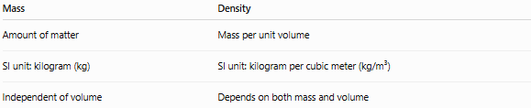
Mass | Density
Amount of matter | Mass per unit volume
SI unit: kilogram (kg) | SI unit: kilogram per cubic meter (kg/m³)
Independent of volume | Depends on both mass and volume

Mass vs. Volume
# Source: AI Source: Provided by: [Data Path: Persons Table -> ID Column: 1, Name_En Column: Motasem Essam] -> From: [ChatGPT] on [7/17/2026]
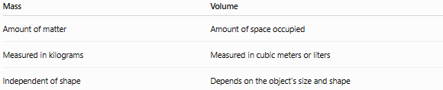
Mass | Volume
Amount of matter | Amount of space occupied
Measured in kilograms | Measured in cubic meters or liters
Independent of shape | Depends on the object's size and shape

Mass vs. Matter
# Source: AI Source: Provided by: [Data Path: Persons Table -> ID Column: 1, Name_En Column: Motasem Essam] -> From: [ChatGPT] on [7/17/2026]

Mass | Matter
Measurable physical quantity | Physical substance
Numerical value | Material that has mass and occupies space
Expressed in kilograms | Not expressed in units

Conclusion
# Source: AI Source: Provided by: [Data Path: Persons Table -> ID Column: 1, Name_En Column: Motasem Essam] -> From: [ChatGPT] on [7/17/2026]
Mass is the measurement of the amount of matter contained in an object. It is one of the seven SI base quantities, with the kilogram (kg) as its standard unit. Unlike weight, mass does not depend on gravity and remains constant regardless of location. Accurate mass measurement, using calibrated balances and appropriate techniques, is essential in science, engineering, manufacturing, healthcare, commerce, and everyday activities.

